|  |  |
| --- | --- |
| Package | Description |
| [**javafx.animation**](https://docs.oracle.com/javase/8/javafx/api/javafx/animation/package-summary.html) | Provides the set of classes for ease of use transition based animations. |
| [**javafx.application**](https://docs.oracle.com/javase/8/javafx/api/javafx/application/package-summary.html) | Provides the application life-cycle classes. |
| [**javafx.beans**](https://docs.oracle.com/javase/8/javafx/api/javafx/beans/package-summary.html) | The package javafx.beans contains the interfaces that define the most generic form of observability. |
| [**javafx.beans.binding**](https://docs.oracle.com/javase/8/javafx/api/javafx/beans/binding/package-summary.html) | Characteristics of Bindings |
| [**javafx.beans.property**](https://docs.oracle.com/javase/8/javafx/api/javafx/beans/property/package-summary.html) | The package javafx.beans.property defines read-only properties and writable properties, plus a number of implementations. |
| [**javafx.beans.value**](https://docs.oracle.com/javase/8/javafx/api/javafx/beans/value/package-summary.html) | The package javafx.beans.value contains the two fundamental interfaces **[ObservableValue](https://docs.oracle.com/javase/8/javafx/api/javafx/beans/value/ObservableValue.html" \o "interface in javafx.beans.value)** and **[WritableValue](https://docs.oracle.com/javase/8/javafx/api/javafx/beans/value/WritableValue.html" \o "interface in javafx.beans.value)** and all of its sub-interfaces. |
| [**javafx.collections**](https://docs.oracle.com/javase/8/javafx/api/javafx/collections/package-summary.html) | Contains the essential JavaFX collections and collection utilities |
| [**javafx.css**](https://docs.oracle.com/javase/8/javafx/api/javafx/css/package-summary.html) | Provides API for making properties styleable via CSS and for supporting pseudo-class state. |
| [**javafx.event**](https://docs.oracle.com/javase/8/javafx/api/javafx/event/package-summary.html) | Provides basic framework for FX events, their delivery and handling. |
| [**javafx.fxml**](https://docs.oracle.com/javase/8/javafx/api/javafx/fxml/package-summary.html) | Contains classes for loading an object hierarchy from markup. |
| [**javafx.geometry**](https://docs.oracle.com/javase/8/javafx/api/javafx/geometry/package-summary.html) | Provides the set of 2D classes for defining and performing operations on objects related to two-dimensional geometry. |
| [**javafx.print**](https://docs.oracle.com/javase/8/javafx/api/javafx/print/package-summary.html) | Provides the public classes for the JavaFX Printing API. |
| [**javafx.scene**](https://docs.oracle.com/javase/8/javafx/api/javafx/scene/package-summary.html) | Provides the core set of base classes for the JavaFX Scene Graph API. |
| [**javafx.scene.canvas**](https://docs.oracle.com/javase/8/javafx/api/javafx/scene/canvas/package-summary.html) | Provides the set of classes for canvas, an immediate mode style of rendering API. |
| [**javafx.scene.chart**](https://docs.oracle.com/javase/8/javafx/api/javafx/scene/chart/package-summary.html) | The JavaFX User Interface provides a set of chart components that are a very convenient way for data visualization. |
| [**javafx.scene.control**](https://docs.oracle.com/javase/8/javafx/api/javafx/scene/control/package-summary.html) | The JavaFX User Interface Controls (UI Controls or just Controls) are specialized Nodes in the JavaFX Scenegraph especially suited for reuse in many different application contexts. |
| [**javafx.scene.control.cell**](https://docs.oracle.com/javase/8/javafx/api/javafx/scene/control/cell/package-summary.html) | The javafx.scene.control.cell package is where all cell-related classes are located, other than the core classes such as [**Cell**](https://docs.oracle.com/javase/8/javafx/api/javafx/scene/control/Cell.html), **[IndexedCell](https://docs.oracle.com/javase/8/javafx/api/javafx/scene/control/IndexedCell.html" \o "class in javafx.scene.control)**, **[ListCell](https://docs.oracle.com/javase/8/javafx/api/javafx/scene/control/ListCell.html" \o "class in javafx.scene.control)**, **[TreeCell](https://docs.oracle.com/javase/8/javafx/api/javafx/scene/control/TreeCell.html" \o "class in javafx.scene.control)**, and **[TableCell](https://docs.oracle.com/javase/8/javafx/api/javafx/scene/control/TableCell.html" \o "class in javafx.scene.control)**. |
| [**javafx.scene.effect**](https://docs.oracle.com/javase/8/javafx/api/javafx/scene/effect/package-summary.html) | Provides the set of classes for attaching graphical filter effects to JavaFX Scene Graph Nodes. |
| [**javafx.scene.image**](https://docs.oracle.com/javase/8/javafx/api/javafx/scene/image/package-summary.html) | Provides the set of classes for loading and displaying images. |
| [**javafx.scene.input**](https://docs.oracle.com/javase/8/javafx/api/javafx/scene/input/package-summary.html) | Provides the set of classes for mouse and keyboard input event handling. |
| [**javafx.scene.layout**](https://docs.oracle.com/javase/8/javafx/api/javafx/scene/layout/package-summary.html) | Provides classes to support user interface layout. |
| [**javafx.scene.media**](https://docs.oracle.com/javase/8/javafx/api/javafx/scene/media/package-summary.html) | Provides the set of classes for integrating audio and video into Java FX Applications. |
| [**javafx.scene.paint**](https://docs.oracle.com/javase/8/javafx/api/javafx/scene/paint/package-summary.html) | Provides the set of classes for colors and gradients used to fill shapes and backgrounds when rendering the scene graph. |
| [**javafx.scene.shape**](https://docs.oracle.com/javase/8/javafx/api/javafx/scene/shape/package-summary.html) | Provides the set of 2D classes for defining and performing operations on objects related to two-dimensional geometry. |
| [**javafx.scene.text**](https://docs.oracle.com/javase/8/javafx/api/javafx/scene/text/package-summary.html) | Provides the set of classes for fonts and renderable Text Node. |
| [**javafx.scene.transform**](https://docs.oracle.com/javase/8/javafx/api/javafx/scene/transform/package-summary.html) | Provides the set of convenient classes to perform rotating, scaling, shearing, and translation transformations for Affine objects. |
| [**javafx.scene.web**](https://docs.oracle.com/javase/8/javafx/api/javafx/scene/web/package-summary.html) | This package provides means for loading and displaying Web content. |
| [**javafx.stage**](https://docs.oracle.com/javase/8/javafx/api/javafx/stage/package-summary.html) | Provides the top-level container classes for JavaFX content. |
| [**javafx.util**](https://docs.oracle.com/javase/8/javafx/api/javafx/util/package-summary.html) | Contains various utilities and helper classes. |
| [**javafx.util.converter**](https://docs.oracle.com/javase/8/javafx/api/javafx/util/converter/package-summary.html) | This package is for standard string converters for JavaFX. |

# JavaFX Layouts

1. **BorderPane** – layout with 5 regions

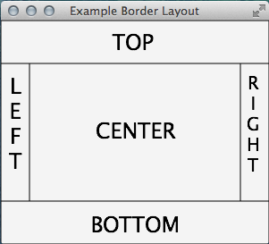

1. **HBox** – arranges nodes horizontally

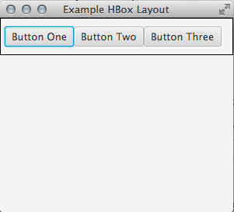

1. **VBox** – arranges nodes vertically *(in the below example the VBox was added to the left region of a BorderPane layout.)*

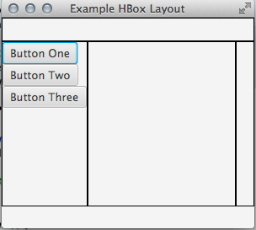

1. **StackPane** – arranges nodes in a single stack *(in the example the StackPane was added to the right region of a BorderPane layout.)*

`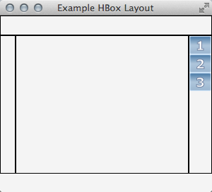

1. **GridPane** – similar to a table design, you can specify row and column

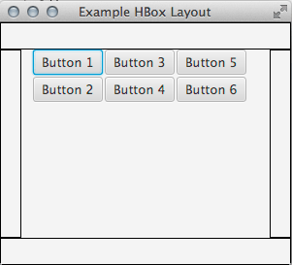

1. **FlowPane** – nodes are added consecutively side by side and wrap at the end of the line

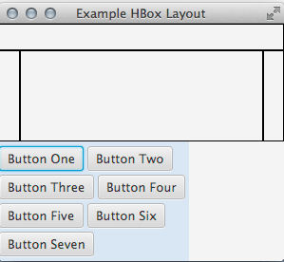

1. **TilePane** – similar to FlowPane, but each tile is considered the same size

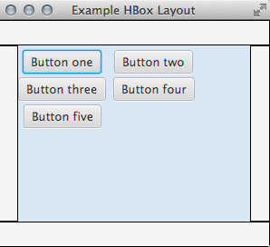

1. **AnchorPane** – allows the developer to anchor nodes to the top, bottom, left or right side.

